**Supplementary Material**

**The influence of *MIR137* on white matter fractional anisotropy and cortical surface area in individuals with familial** **risk for psychosis**

Bob O. Vogel1*, Tristram A. Lett1*, Susanne Erk1, Sebastian Mohnke1, Carolin Wackerhagen1, Eva J. Brandl1, Nina Romanczuk-Seiferth1, Kristina Otto2, Janina I. Schweiger2, Heike Tost2, Markus M. Nöthen3,4, Marcella Rietschel2, Franziska Degenhardt3, Stephanie H. Witt2, Andreas Meyer-Lindenberg2*, Andreas Heinz1*, Henrik Walter1*

1 Department of Psychiatry and Psychotherapy, Charité Universitätsmedizin Berlin, Charitéplatz 1, 10117 Berlin, Germany

2 Central Institute of Mental Health, University of Heidelberg, J 5, 68159 Mannheim, Germany

3 Department of Genomics, Life & Brain Center, University of Bonn, Sigmund-Freud-Str. 25, 53127 Bonn, Germany

4 Institute of Human Genetics, University of Bonn, Sigmund-Freud-Str. 25, 53127 Bonn, Germany

* Authors contributed equally

**1. Supplementary Methods**

1.1 Image acquisition

DW-MRI images were acquired using GRAPPA. DW-MRI images collected at Charité Universitätsmedizin Berlin had a spatial resolution of 2mm isotropic voxel dimensions, 61 slices, 64 gradient non-collinear directions with a b value = 1000 s/mm2, TR = 8200 ms, TE = 92 ms. DW-MRI collected at the Life and Brain Center of the University of Bonn had a spatial resolution of 1.7mm isotropic voxel dimensions, 72 slices, 60 non-collinear gradient directions with a b value = 1000 s/mm2, TR = 12000 ms, TE = 100 ms. DW-MRI images collected at the Central Institute of Mental Health Mannheim had a spatial resolution of 2mm isotropic voxel dimensions, 64 slices, 60 gradient, non-collinear directions with a b value = 1000 s/mm2, TR = 14000 ms, TE = 86 ms.

Structural scans were acquired using T1-weighted three-dimensional magnetization prepared rapid gradient echo (MP-RAGE) sequence with an isotropic spatial resolution of 1 mm3 (repetition time (TR) = 1.57 s, echo time (TE) = 2.74 ms, flip angle = 15°).

Quality control measurements were conducted at all three study sites utilizing a multicenter quality assurance protocol (Friedman and Glover, 2006), which revealed stable signals over time and comparable quality between sites. Additionally, we included site as a covariate for all statistical analyses.

1.2 Processing of DW-MRI Images

After visual inspection, all DW-MRI scans underwent automated quality control, eddy current, and motion correction using DTIprep (Oguz et al., 2014). MCFLIRT was used for averaging the b0 images and BET was used for skull stripping the images (Smith, 2002). DTIFit was employed to create fractional anisotropy (FA) images by fitting a tensor model at each voxel (Smith et al., 2004). FSL tract-based spatial statistics (TBSS) version 1.2 steps 1-4 were performed using each subject’s FA images (Smith et al., 2006). First, the FA images underwent nonlinear registration to the FMRIB58_FA target image. The mean FA image was iteratively generated. The data was then aligned to MNI 152 standard space using an affine transformation. An average white matter skeleton was generated from the mean of all subject’s transformed FA images with a threshold of 0.2. Last, the FA data of each subject was projected onto the white matter skeleton. After projection, we calculated the mean squared and maximum squared projection distances across all voxels along the skeleton. Comparing the projection distances between groups allows for the comparison of quantitative evaluation parameters that may suggest poor image quality or failures to correctly registering the images. The mean squared projection distance of control subjects (3.2 ± .3) did not differ significantly from the familial risk group (3.17 ± .32; T(351)=.08; P=.94). Also, the maximum squared projection distance of control subjects (170.07 ± 28.1) did not differ significantly from the familial risk group (166.89 ± 25.35; T(351)=1.15; P=.25).

1.3 Processing of Structural Images

Cortical reconstruction was performed on all T1-weighted images using the Freesurfer image analysis suite (<http://surfer.nmr.mgh.harvard.edu/>). The technical details of these procedures are described in prior publications (Fischl and Dale, 2000; Fischl et al., 2002; Fischl et al., 2004; Fischl et al., 1999a; Fischl et al., 1999b). In brief, this process includes motion correction and averaging of multiple volumetric T1 weighted images, removal of non-brain tissue, automated Talairach transformation, segmentation of the subcortical white matter and deep gray matter volumetric structures, intensity normalization, tessellation of the gray matter white matter boundary, automated topology correction, and surface deformation. A number of deformable procedures were performed including surface inflation, registration to a spherical atlas which is based on individual cortical folding patterns to match cortical geometry across subjects, and creation of a variety of surface based data including maps of curvature and sulcal depth. Both intensity and continuity information from the entire three dimensional MR volume in segmentation and deformation procedures to produce representations of cortical thickness, calculated as the closest distance from the gray/white boundary to the gray/CSF boundary at each vertex on the tessellated surface (Fischl and Dale, 2000).

**2. Supplementary Figures**

**Enrolment**

**Full structural  
 MRI sample**

**DW-MRI  
subsample**

Participated in study (N=562)

Excluded (N=134)

Not psychosis relative or healthy   
 control (N=107)

Missing genetic data (N=15)

Missing demographic data (N=1)

Missing T1 scan (N=11)

T1-weighted MRI scans (N=428)

**Included in CT and SA analysis (N=426)**

Subjects that also underwent DW-MRI (N=380)

**Included in FA analysis (N=357)**

Excluded (N=2)

Failed QC structural MRI (N=2)

Excluded (N=23)

Failed QC DW-MRI (N=23)

**Figure S1:** Flow-chart of the study enrolment and analysis process

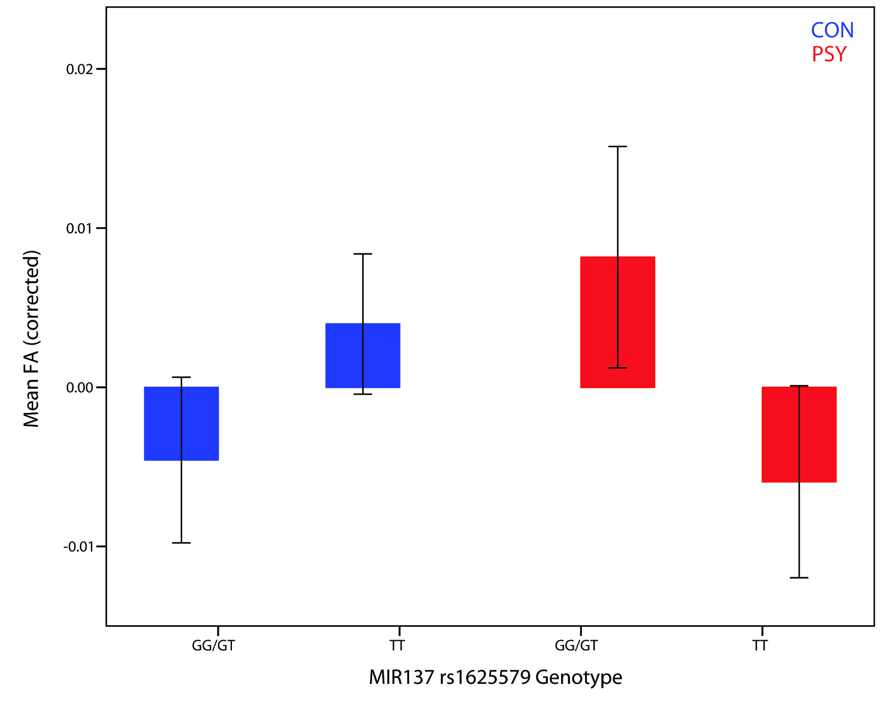

**Figure S2:** The mean cluster FA values from the *MIR137* rs1625579 genotype-by-group interaction (14 870 voxels, lowest PFWE=0.005). Blue bars correspond to control subjects, red bars correspond to individuals with familial risk for psychosis. Error bars represent 95% confidence intervals. The mean FA values have been corrected for sex, age and site. CON, control subjects; FA, fractional anisotropy; PSY, psychosis familial risk group.

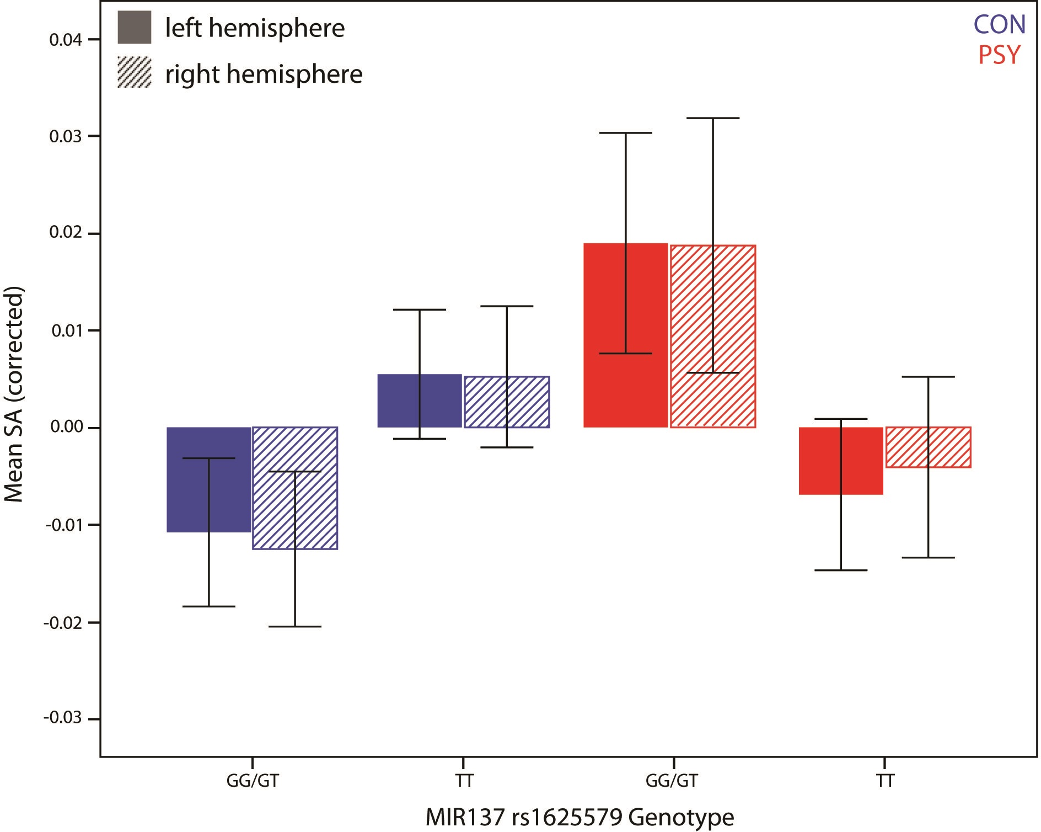

**Figure S3:** The mean cluster SA values from the *MIR137* rs1625579 genotype-by-group interaction for each hemisphere (left: 16 951.95 mm²; lowest PFWE=0.004; right: 31 556.26 mm²; lowest PFWE=0.005). Blue bars correspond to control subjects. Red bars correspond to individuals with familial risk for psychosis. Solid bars represent mean SA in the left hemisphere and striped bars represent mean SA in the right hemisphere. Error bars represent 95% confidence intervals. Mean SA values were corrected for sex, age and site. CON, control subjects; SA, cortical surface area; PSY, psychosis familial risk group.

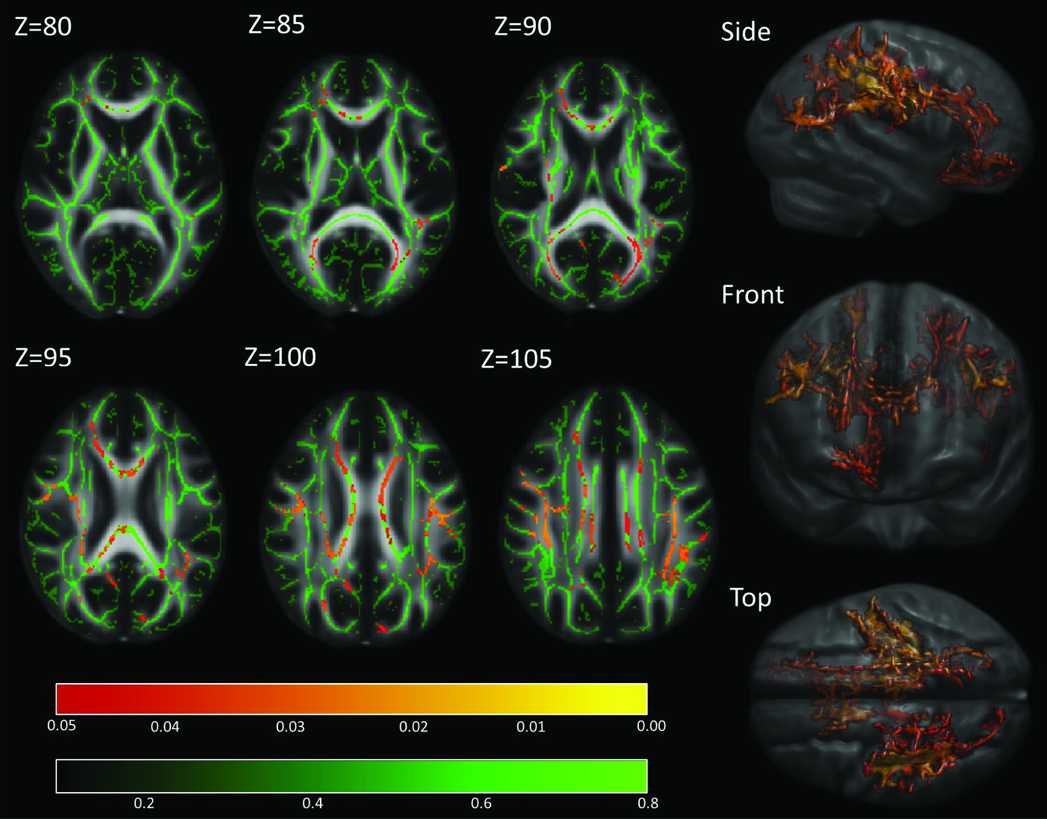

**Figure S4:** *MIR137* rs1625579 risk genotype is associated with lower white matter fractional anisotropy (FA) in the familial risk group. Areas ranging from red to yellow correspond to PFWE <0.05 and PFWE <0.01, respectively. Areas in green represent the mean FA skeleton values of all subjects, ranging from 0.1 to 0.8, superimposed on the FMRIB58_FA standard space image.

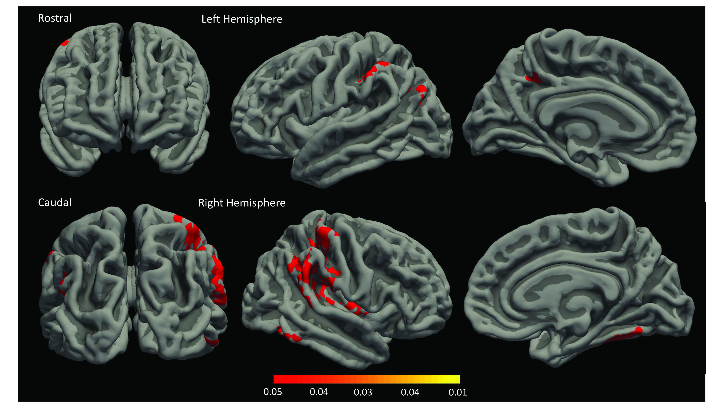

**Figure S5:** *MIR137* rs1625579 risk genotype is associated with higher surface area in control subjects. Areas ranging from red to yellow correspond to PFWE <0.05 and PFWE <0.01, respectively, superimposed on the midthickness projected surface.

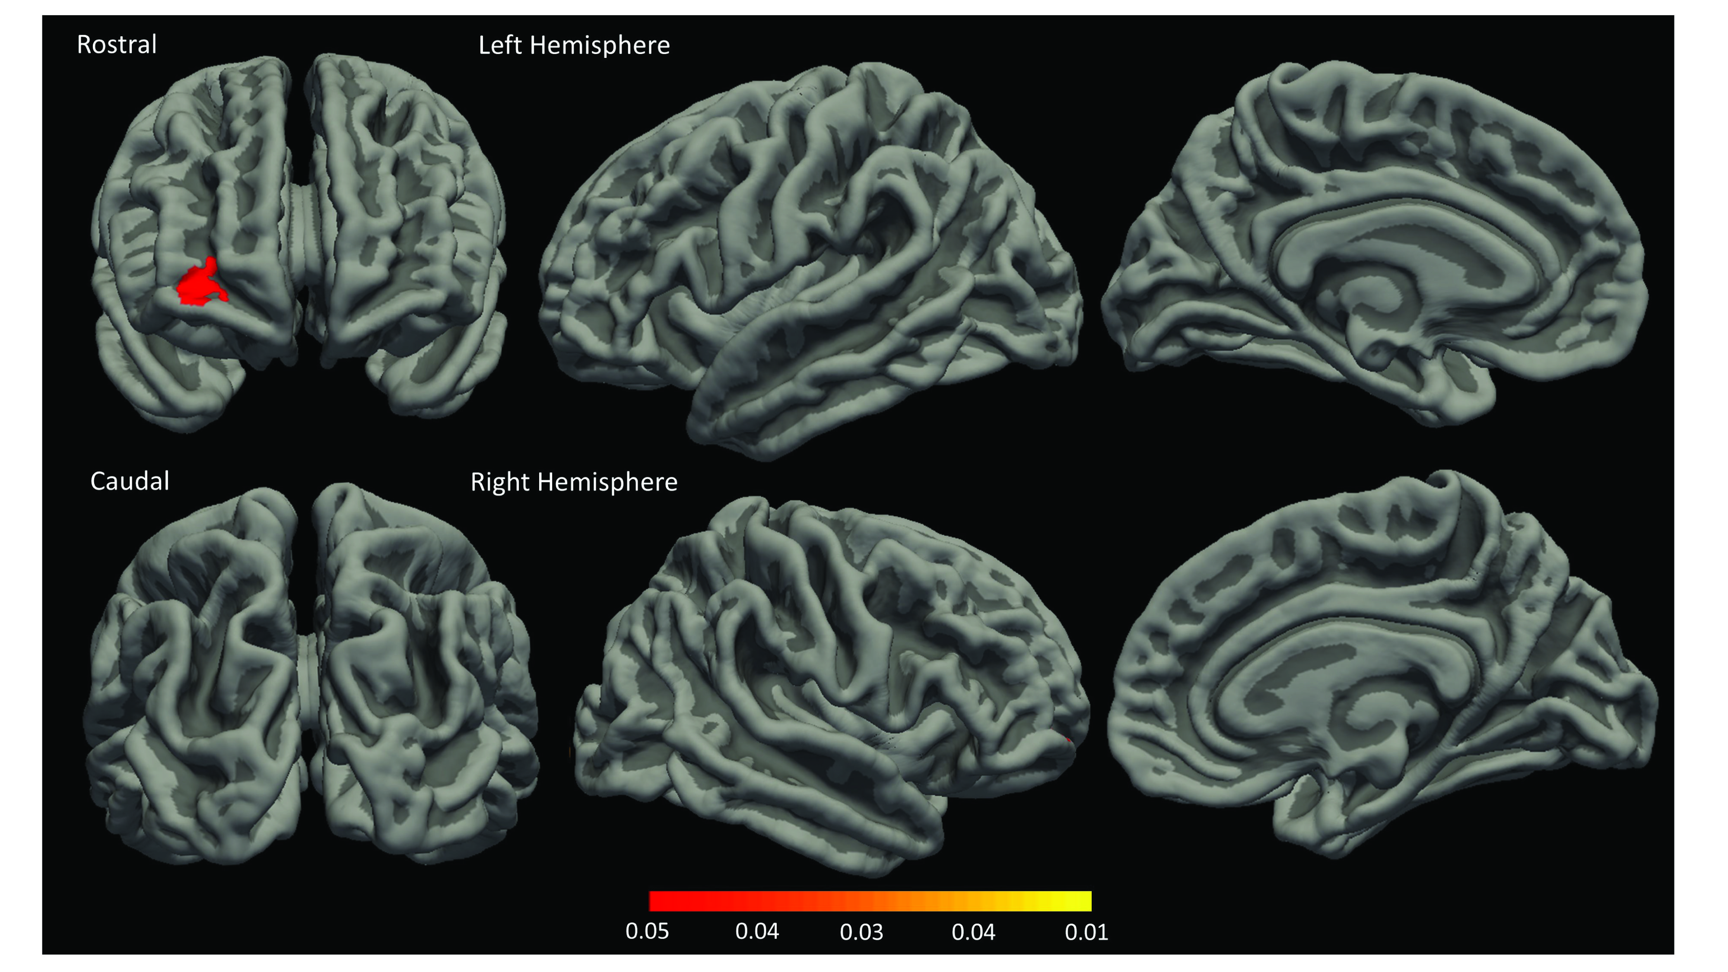

**Figure S6:** *MIR137* rs1625579 risk genotype is associated with lower surface area in the familial risk group. Areas ranging from red to yellow correspond to PFWE <0.05 and PFWE <0.01, respectively, superimposed on the midthickness projected surface.

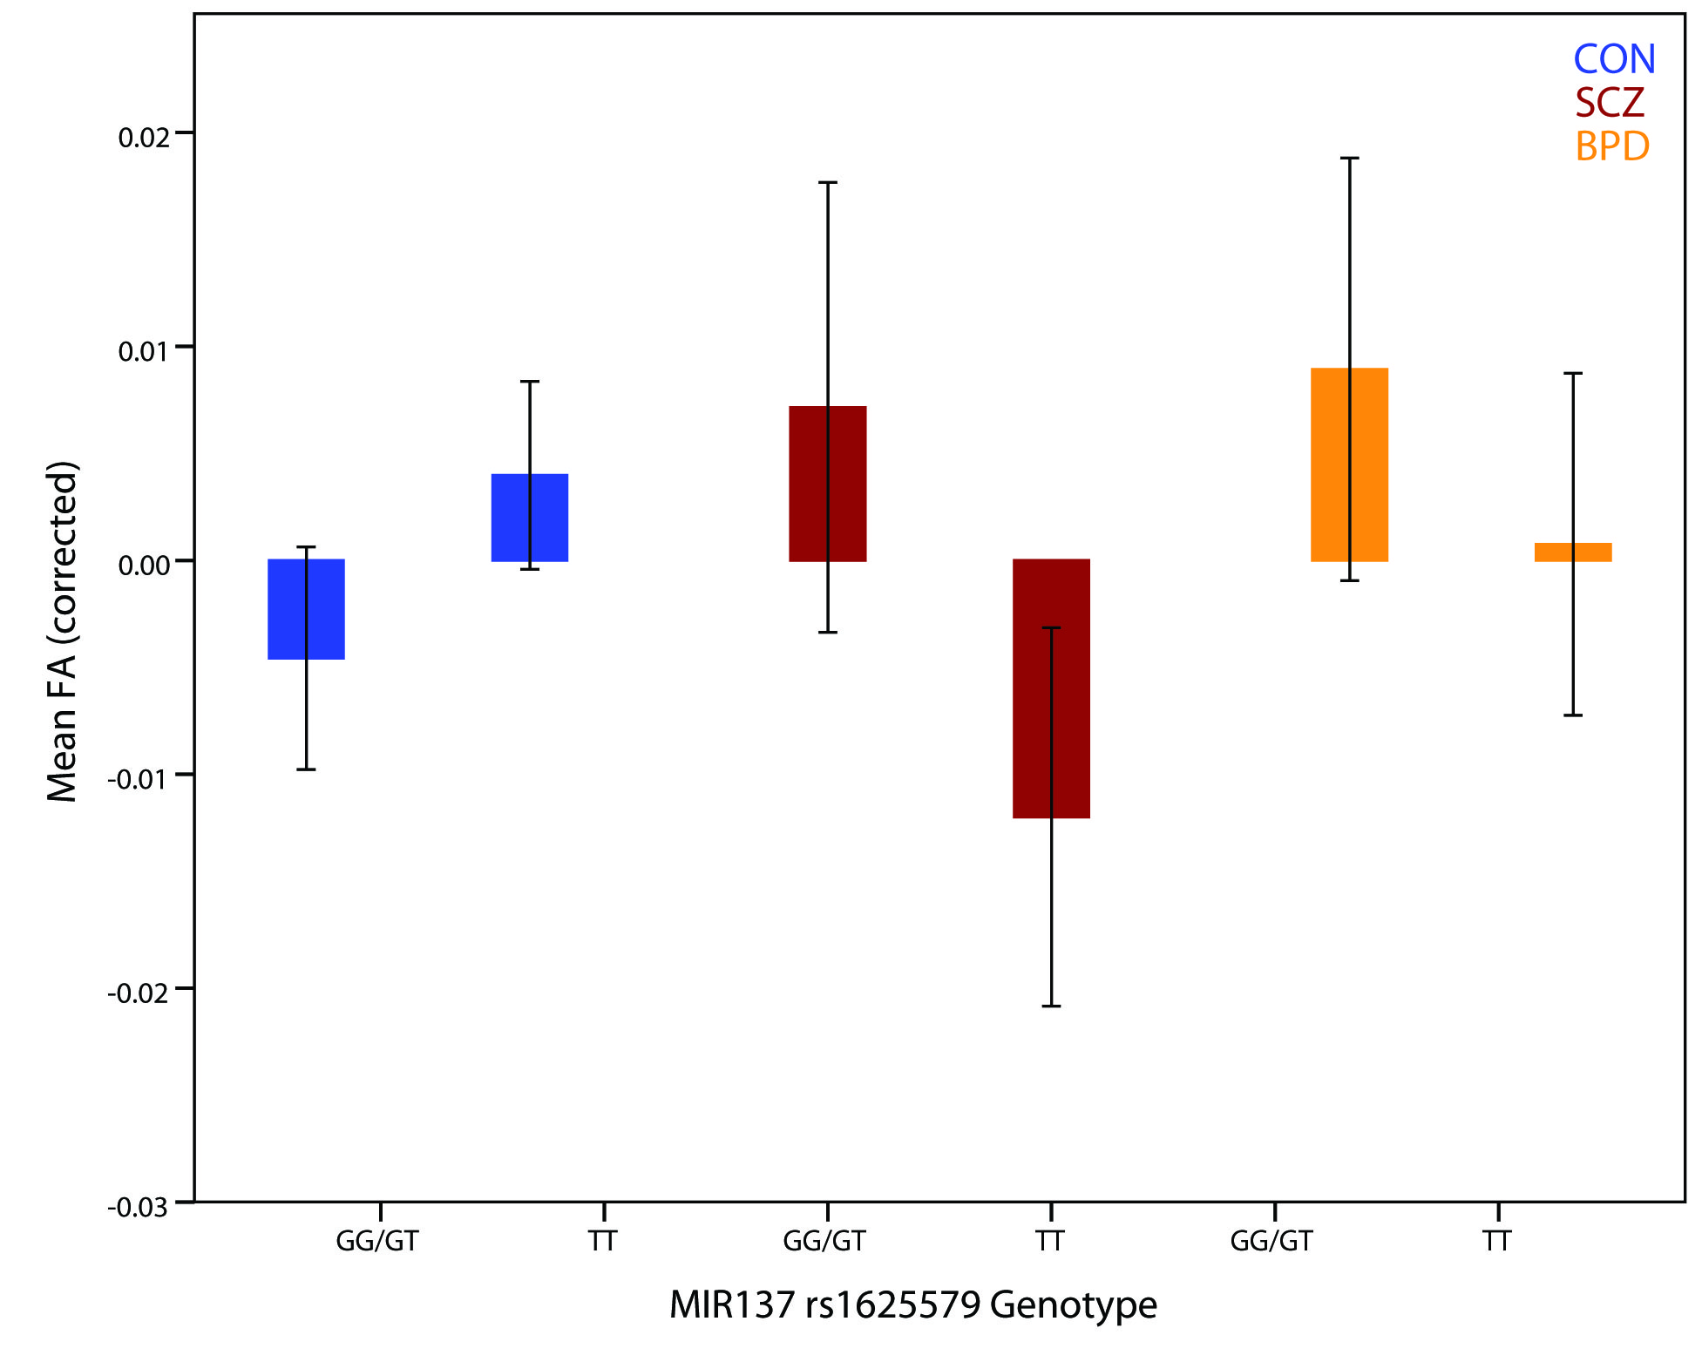

**Figure S7:** The effect of *MIR137* rs1625579 risk genotype on white matter FA, separately for control subjects, schizophrenia relatives and bipolar relatives. Blue bars correspond to control subjects, red bars correspond to relatives of patients with schizophrenia and orange bars correspond to relatives of patients with bipolar disorder. Error bars represent 95% confidence intervals. Mean centered FA values have been corrected for sex, age and site and were extracted from the largest cluster of the interaction (Figure 1). BPD, relatives of patients with bipolar disorder; CON, control subjects; FA, fractional anisotropy; SCZ, relatives of patients with schizophrenia.

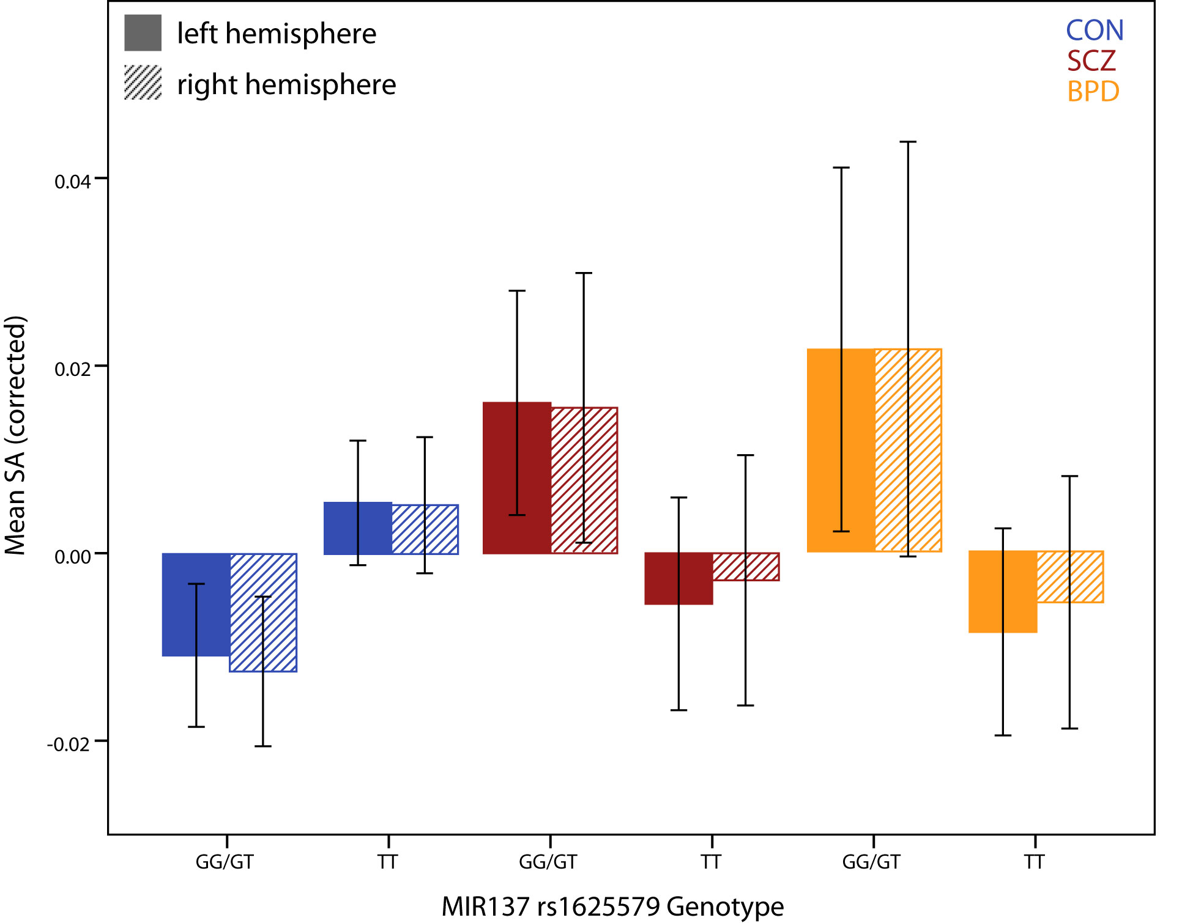

**Figure S8:** The effect of *MIR137* rs1625579 risk genotype on cortical SA, separately for control subjects, schizophrenia relatives and bipolar relatives. Blue bars correspond to control subjects, red bars correspond to relatives of patients with schizophrenia and orange bars correspond to relatives of patients with bipolar disorder. Error bars represent 95% confidence intervals. Mean centered SA values have been corrected for sex, age and site and were extracted from the largest cluster of the interaction (Figure 2). BPD, relatives of patients with bipolar disorder; CON, control subjects; SA, Cortical surface area; SCZ, relatives of patients with schizophrenia.

**References**

Fischl, B., Dale, A.M., 2000. Measuring the thickness of the human cerebral cortex from magnetic resonance images. Proceedings of the National Academy of Sciences 97(20), 11050-11055.

Fischl, B., et al., 2002. Whole Brain Segmentation. Neuron 33(3), 341-355.

Fischl, B., et al., 2004. Sequence-independent segmentation of magnetic resonance images. Neuroimage 23, S69-S84.

Fischl, B., Sereno, M.I., Dale, A.M., 1999a. Cortical Surface-Based Analysis. Neuroimage 9(2), 195-207.

Fischl, B., Sereno, M.I., Tootell, R.B.H., Dale, A.M., 1999b. High-resolution intersubject averaging and a coordinate system for the cortical surface. Hum Brain Mapp 8(4), 272-284.

Friedman, L., Glover, G.H., 2006. Report on a multicenter fMRI quality assurance protocol. Journal of magnetic resonance imaging : JMRI 23(6), 827-839.

Oguz, I., et al., 2014. DTIPrep: quality control of diffusion-weighted images. Frontiers in neuroinformatics 8, 4.

Smith, S.M., 2002. Fast robust automated brain extraction. Hum Brain Mapp 17(3), 143-155.

Smith, S.M., et al., 2006. Tract-based spatial statistics: voxelwise analysis of multi-subject diffusion data. NeuroImage 31(4), 1487-1505.

Smith, S.M., et al., 2004. Advances in functional and structural MR image analysis and implementation as FSL. Neuroimage 23 Suppl 1, S208-219.